Congratulations, Tony Ames
Congratulations to Tony Ames, who recently became Minnesota’s third Grand Life Master. He also became only the second ACBL tournament director to attain Grand Life Master status. The other was the late Max Hardy.
I first met Tony 54 years ago when he organized a bridge club during his sophomore year at St. John’s University. Fifteen tables showed up. Of the entire assembly, only about five players had any notion of the rules of the game, but Tony organized the group, gave a short opening lesson, produced an old grimy set of aluminum boards, and proceeded to run a Mitchell movement. True to Tony’s style, he didn’t limit himself to the role of director; he played every board.
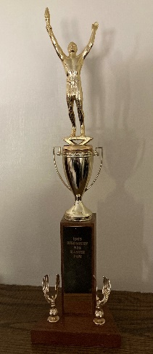
Tony soon coordinated a smaller group to make the fifteen-mile trek to the Monday and Thursday sessions of the St. Cloud Duplicate Bridge game. In those days, the game was played in a basement meeting room in the city’s “labor temple.” The atmosphere was blue with smoke; adding to the dinge, there was a small bar in the next room, so almost every table sported glasses of beer or something stronger. The game was lively, ten tables or more; it welcomed the additional one or two tables of St. John’s students with open arms.
Tony couldn’t be contained in smokey little rooms. By the next spring, he showed up in my dorm room at 3 p.m. on a Friday afternoon with the idea to run off to a bridge tournament in South Dakota. The picture to the right is the fruit of Tony’s first tournament triumph. The next spring, he found me in the school cafeteria at noon on a Friday and made the outrageous proposal to take a jaunt to Cleveland to play in the 1969 Spring Nationals. We drove through the night to reach the playing site in time for a warm-up session, the Cuyahoga Pairs, Tony’s first national win, however modest. The next day, we had to settle for fifth in the Kem Card Pairs, a 0-50 event, disappointing Tony’s enormous ambition but not an altogether failure.
In the years that followed, we seized every opportunity to play in big tournaments. I remember playing against Harry Fishbein in the Leamington ballroom at the 1969 Summer Nationals. Fishbein was the proprietor of the plush Mayfair Club in New York City, and he was nattily dressed in an expensive sports coat and bow tie at the 1969 nationals. I was embarrassed to be sitting to his left wearing grungy Bermuda shorts; Tony, straight from his delivery job, had grease under his fingernails and was outfitted in a hunter-green jump suit, a one piece which except for the color might have passed for a prison uniform. Another time I remember meeting Tony on the Northwestern Medical campus for a Muncie, Indiana sectional. Tony was in Chicago for an accounting seminar; I was attending graduate school at a nearby Indiana college.
From 1995 to 2000, Tony and I were part of upwards to ten KO or Swiss Team wins in Regional tournaments in the Chicago area. All of them were on teams that included Peggy Kaplan, Minnesota’s first Grand Life Master. The most memorable was 25 years ago this month when our team consisting of Tony, Peggy, Dick Bruno, Kerry Smith, and myself made our way to the finals of the Lake Geneva knockout to face the Paul Soloway team. The Soloway team consisted of Soloway (1st at the time on the all-time ACBL masterpoint list), Mike Passell (2nd), Mark Lair (4th) and Gaylor Kasle (9th). The weak sister was the client, Malcolm Brachman, a nuclear physicist with a degree from Yale and a doctorate from Harvard, who himself had won nine national championships and the 1979 Bermuda Bowl. In the key hand, the key decisions stemmed from judgments made by Peggy of Brachman, and by Soloway of Tony.
♠ K 10 7 5 2
♡ 7
♢ A 6 3
♣ A J 9 4
♠ A 6 3 ♠ J 9
♡ K 10 6 4 3 2 ♡ J 9 8 5
♢ Q 9 4 ♢ 10 7 5 2
♣ 5 ♣ 10 8 3
♠ Q 8 4
♡ A Q
♢ K J 8
♣ K Q 7 6 2
Koch Kasle Ames Soloway
- 1♠ Pass 2♣
Pass 3♡ Pass 3♠
Pass 4♢ Pass 4NT
Pass 5♡ Pass 6♣
Against the club slam, I led the four of diamonds to Soloway’s jack. He drew three rounds of trumps ending in dummy, and came off the board with a low spade to Tony’s 9, his queen, and my ace. Soloway won the diamond return and played the ♠8. When I played low, he pondered for a full two minutes. He eventually concluded that Tony was a strong enough player to have played the 9 from 9-doubleton. He called for the ♠10 and Tony grabbed the setting trick.
At the other table, Peggy was declarer and Mike Passell was sitting in my chair. Passell also captured the ♠Q with the ace. Peggy, however, took due note of Brachman’s ♠9, and considered that the ♠9 from ♠J9 was forced, while the ♠9 from ♠9x would have been a really good play. She decided that Brachman was not up to that level, and called for the ♠K, chalking up a 16-IMP gain.
While Peggy was the hero and Tony received a glowing assessment from one of the best players in the world, the goats were Passell and Koch. Soloway’s 3♠ raise promised three spades. That should have induced the West defenders to duck smoothly when a spade was led to the queen. When a spade was led on the next round back toward the ♠K10, they would duck again. Now declarer would virtually always insert the ♠10, and the defense would be assured of two spade tricks.
In the early 2000s, after we had attained the magic age of 55, Tony began to insist that we play in the Senior Team Trials (two in Vegas and one in San Antonio), and in the Senior Knockouts at the ACBL Fall Nationals. Some of my fondest bridge memories were trips to the Fall Nationals in New Orleans (2003), Orlando (2004), Denver (2005), and Honolulu (2006). The highlight of these four tournaments was Tony’s biggest bridge success, the Senior Knockouts at Orlando in 2004. This event almost didn’t happen for us. In early October, Tony made arrangements with a Milwaukee pair to form a team. These players then augmented the team to six by adding two players from Raleigh, NC. A week later, Tony was notified that the Raleigh players had augmented again by adding two more. All of a sudden, the team had eight players, and Tony and I were the odd-pair out.
These hiccups never kept Tony down. He immediately called Rod Beery and Mary Egan of Lincoln, NE, and we had a team. The drawback was that Tony and I had played together only 3 times since the 2003 Fall Nationals. We had accomplished one small victory during that year, beating a Nebraska team in a semi-final match in the District GNTs. Our opponents included Beery and Egan. If the only people we could beat were our teammates, how good could this national team be? We were seeded 23rd in a 33-team field.
We survived the first day, losing to the 12th seed but beating the 5th seed, which allowed us to advance.
The second day we met our one-time teammates, the Milwaukee and Raleigh pairs. The drama intensified when we discovered there was no “third pair!” It was extremely satisfying to dispatch this foursome convincingly.
The third day brought the third seed—Bobby Wolff, 11 world titles; Dan Morse, World Senior Teams champion and bronze medalist in the 2003 Bermuda Bowl; two Canadian professionals who had narrowly lost to the Nickel team in 1995 Bermuda Bowl finals; Dennis Dawson, Santa Fe pro, currently 7th on the Barry Crane list; Carolyn Lynch, his very comely client and the team’s obvious weak link, but currently 28th on the Barry Crane list with 893 points. With Wolff and Morse out of the lineup, we built a 50-IMP lead in the first 10 boards, and increased that lead to 65 IMPs at the three-quarter mark. After a full 64 boards, the team met in the hall and everyone was in despair; one teammate was ready to concede. But after a furious count, Tony tabulated the fourth quarter score at 67 to 4. As he commented later, getting blitzed by 63 in the fourth quarter is why 65-IMP leads are so useful.
The fourth day we sat down against a team composed solely of professionals: Allan Siebert (No. 23 on the all-time ACBL list), Alan Stout (No. 26), David Siebert (No. 31), Randy Pettit (No. 73), Don Stack (No. 88), and John Onstott (No. 116). Onstott had one distinction the others lacked: two World Senior Championships. The match was a slugfest. We found ourselves down 4 IMPs with one board to play. Tony and Pettit held a monster hand. Pettit made a second-round jump shift, and his partner found it impossible to put on the brakes, reaching an unmakable slam. Tony and I had a strong club opening and a negative 1♢ response, and resisted the temptation to move beyond game.
Day five was the semi-finals. The format now included not only bidding screens, but open and closed rooms, Vugraph streaming worldwide, and quirky commentators, including David Bird, analyzing every bid and play. Our opponents were the Rosenkranz team: George; his partner Miguel Reygadas; Roger Bates (No 37); Bruce Ferguson (No. 52); Neil Chambers and John Schermer (the best pair in America that no one has heard of). Schermer and Chambers were fresh from winning the World Seniors in Istanbul; since then, they have added a second World Seniors title. There was one particularly notable deal in this match, showcasing Tony’s card reading skills:
♠ 9 8 3
♡ A Q 9 8 7 3
♢ K 3
♣ J 4
♠J led
♠ K 6 4
♡ 2
♢ J 8 7 4
♣ A K Q 7 6
Tony reached 3NT after West had opened 1♣. The lead was the ♠J which presented Tony with a seventh trick. Tony ostensibly needed to find West with both the ace of diamonds and king of hearts—not terribly implausible. It was natural to run the clubs before taking a position in the red suits, but he couldn’t afford to do that because he needed a second entry to his hand. So, Tony led a diamond and was pleased when West rose with the ace, with East following with the nine (upside-down count). West now cashed three spade tricks, with dummy throwing a heart, East the six of diamonds. Now West went into a long huddle and emerged with a low heart.
Tony considered whether his original plan to play West for both the ace of diamonds and king of hearts was still viable. First, what about points? West had shown up the ace and jack of spades and the ace of diamonds―nine in all. There was room in his hand for the queen of diamonds and jack of hearts, increasing his total to twelve, enough for a routine opening bid. The king of hearts was not essential.
What about the play in diamonds? If West had the ace of diamonds without the queen, he might have had some significant concern about rising with the ace on the first lead of the suit without establishing both the king and queen of diamonds as easy tricks. With ♢Axxx, ♢Axx, or even ♢Ax, West would surely play low on the first diamond lead. What then accounts for the play of the ace on the first round? Two reasonable explanations are that West has the stiff ace or a doubleton ace-queen.
What about East’s diamond signals? He played the nine on the first round and discarded the six. They play upside-down count, which meant East’s ♢9 showed an odd number; and his ♢6 might have been current count showing five. He decided to back his hunch about the doubleton ♢AQ. He rose with the ace of hearts and played the king of diamonds. Down came the ♢Q. He had nine tricks for a 12-IMP pickup in a match decided by 2 IMPs.
Day six found us in the finals against a team of California professionals, who had won the Senior Swiss Teams three months earlier at the Summer Nationals, blitzing the field by winning 150 out of 160 victory points on the last day. They were led by Mike Shuman (No. 27), Gene Simpson (No. 35), Hamish Bennett (No. 76), and Chris Larsen, a native Norwegian and frequent high finisher in American and world events. We stayed close in the match by bidding good games and slams missed at the other table. My favorite was this gem by Tony on the 58th board that vaulted us into the lead:
♠ A 9 5 4
♡ A Q 8 7 6 3
♢ A K 4
♣ —
♡10 led
♠ Q 7 3 2
♡ 9
♢ 9 7 6
♣ Q 10 9 7 3
At our table, we reached four spades after Simpson opened 1♣ in the West seat and Larsen had responded 1♡. Simpson led the ♡10. Tony won the ace and immediately played the ♡Q, ruffing Larsen’s king. He crossed to the ♢A, and led the ♡8, running it when Larsen played low. Simpson ruffed ♠10, and returned a diamond to dummy’s king. Tony cashed the ♠A and led a fourth heart, ruffing Larsen’s ♡J. This was overruffed by Simpson, who had started with ♠KJ10. That was the defense’s last trick when Tony pulled the outstanding trump with the ♠9. Vugraph proclaimed: “Declarer is a dirty filthy spot watcher.” But it was a 10-IMP gain with six boards to play.
Four boards later, Simpson opened 1♢ and I overcalled 1♠. Tony bid 2♡, and I raised him to game on four hearts to the king and a 10-count. Tony had an 11-count, but made his contract by careful play. This was a 6-IMP gain putting us up by 3 with two boards to play. Vugraph chirped: “Cinderella ascendant!” The last boards were flat, and Tony was a champion. Tony’s three sons were caddying at the 2004 Fall Nationals. Each sought Tony out and congratulated him. It was a euphoric moment for everyone.
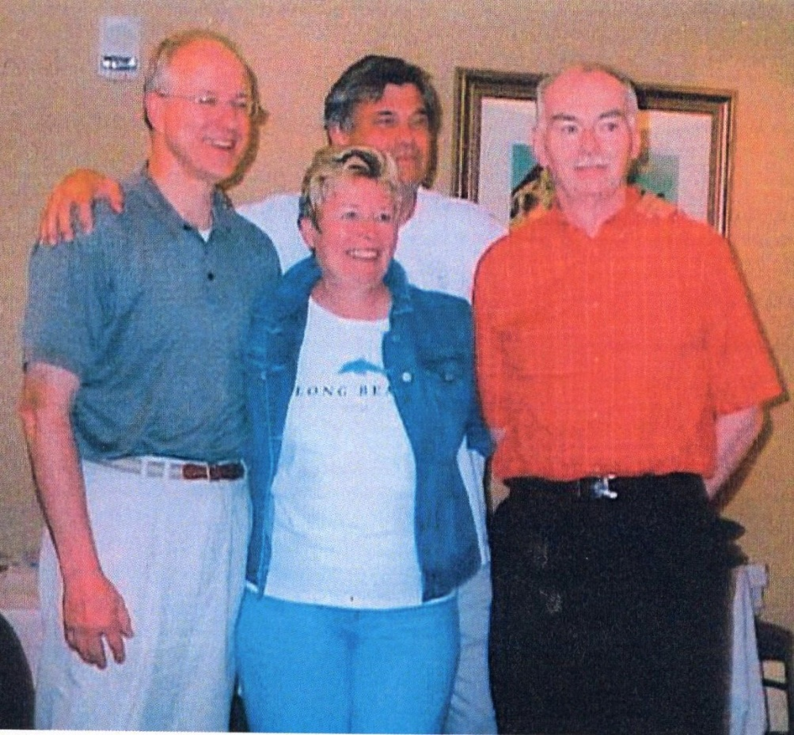

Winning a national event is only one step on the road to Grand Life Master. The other is getting to 10,000 master points. In 2004, Tony was a little more than halfway there. His problem was that as an active tournament director, he had limited opportunities to accumulate points. This is a reason that with the exception of Tony and Max Hardy, no ACBL tournament director has ever become a Grand Life Master. But Tony persevered, playing primarily pairs’ events at regionals and otherwise every chance he got, even if it meant pinch-hitting at some of his own games. Here is a deal from a Grand Slam Club game in which he partnered Don Priewert against Terry Beckman and me:
♠ 6
♡ A K 10 9 8 6 4
♢ K J 5
♣ 10 9
♠ K 7 5 2 ♠ Q 10 9 4
♡ Q J 7 3 ♡ ―
♢ 10 ♢ A 7 4 3 2
♣ K 8 3 2 ♣ Q 7 6 4
♠ A J 8 3
♡ 5 2
♢ Q 9 8 6
♣ A J 5
West North East South
― 1♡ Dbl Rdbl
1♠ 3♡ Pass 3NT
Dbl All Pass
Tony was South and he decided he preferred to be at the controls in 3NT instead of Don playing 4♡. The lead was a low spade to the queen and ace. Tony led a heart and won the ♡10 when West played low. At this point, six hearts were available for the taking but Tony realized that a club shift would lead to five tricks for the defense before Tony could get back to dummy. So, Tony looked to other alternatives: 3 hearts, 3 diamonds, the black aces, and a ninth trick in one of the black suits. On the ♢K, East won the ace, and played the ♠10. Tony covered, creating a frozen suit which neither side could attack without surrendering a trick. West shifted to a club to East’s queen and ace.
Tony took his 3 diamond tricks, and led a second heart toward dummy. West’s jack forced the ace. If Tony cashed the king, the defenders would again eventually come to five tricks. Hearts, like spades, were frozen, so Tony abandoned his heart winner and led the ♣10 to West’s king, creating this position:

♠ ―
♡ K 10 9
♢ ―
♣ —
♠ x ♠ 9 x
♡ Q 7 ♡ ―
♢ ― ♢ ―
♣ — ♣ x
♠ 8 3
♡ —
♢ ―
♣ J
West exited with a spade as the lesser evil. East won his nine but had to concede a trick in each black suit.
With declarer play like that, it is not surprising that Tony has finally achieved his goal. He is a worthy addition to the list of ACBL Grand Life Masters. He was the primary architect of his team’s national triumph in 2004, and, despite his director’s duties, he has at last had time to cobble together enough master points to reach 10,000. Tony is in the top tier of popular players in Minnesota, and everyone celebrates with him in his accomplishment. May he enjoy his new well-earned status for many years to come.

